**Superset ID: 6394725**

**ReactJS-HOL**

**HANDS ON-3:**

Create a react app for Student Management Portal named scorecalculatorapp and create a function component named “CalculateScore” which will accept Name, School, Total and goal in order to calculate the average score of a student and display the same.

1. Create a React project named “scorecalculatorapp” type the following command in terminal of Visual studio:



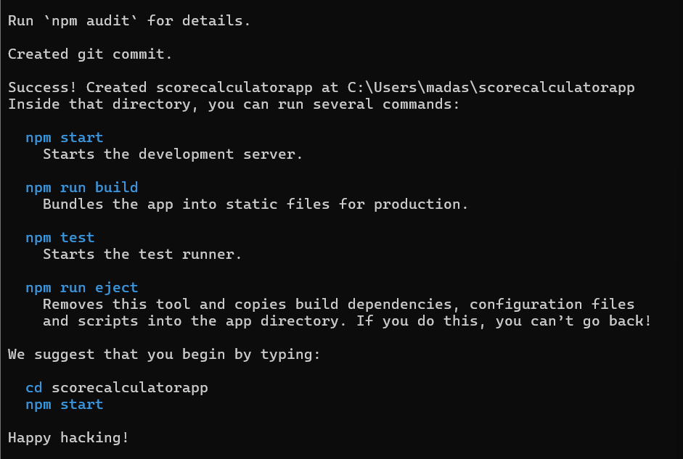

1. Create a new folder under Src folder with the name “Components”. Add a new file named “CalculateScore.js”

1. Type the following code in CalculateScore.js

import '../Stylesheets/mystyle.css';

const percentToDecimal = (decimal) => {

return decimal.toFixed(2) + '%';

};

const calcScore = (total, goal) => {

return percentToDecimal(total / goal);

};

export const CalculateScore = ({ Name, School, total, goal }) => (

<div className="formatstyle">

<h1 style={{ color: 'brown' }}>Student Details:</h1>

<div className="Name">

<b><span>Name: </span></b>

<span>{Name}</span>

</div>

<div className="School">

<b><span>School: </span></b>

<span>{School}</span>

</div>

<div className="Total">

<b><span>Total: </span></b>

<span>{total} Marks</span>

</div>

<div className="Score">

<b>Score: </b>

<span>{calcScore(total, goal)}</span>

</div>

</div>

);

1. Create a Folder named Stylesheets and add a file named “mystyle.css” in order to add some styles to the components:

.Name{

font-weight:300;

color: blue;

}

.School{

color:crimson;

}

.Total{

color: darkmagenta;

}

.formatstyle{

text-align: centre;

font-size: large;

}

.Score{

color:forestgreen;

}

1. Edit the App.js to invoke the CalculateScore functional component as follows:

import logo from './logo.svg';

import './App.css';

import { CalculateScore } from './Components/CalculateScore';

function App(){

return(

<div>

<CalculateScore Name={"Steeve"}

School={"DNV Public School"}

total={284}

goal={3}

/>

</div>

)

}

export default App;

1. In command Prompt, navigate into scorecalculatorapp and execute the code by typing the following command:



1. Open browser and type “localhost:3000” in the address bar:

